Burlingame Public Library
Lane Community Room - Request to Schedule Event
Please complete this form and return it to
Sidney Poland - poland@plsinfo.org - 650-558-7404

Contact Information
Contact Person | Click or tap here to enter text.
Group Name | Click or tap here to enter text.
Address | Click or tap here to enter text.
Phone # | Click or tap here to enter text.
E-mail address | enter email address.

Event Information
Event Date | Click or tap to enter a date.
Event Time | Click or tap here to enter text.
Nature of Event | Enter nature of event here.
Estimated Attendance  Seating Capacity 80 | Click or tap here to enter text.
Presentation Device | PC ☐ Apple ☐ None ☐

Room Setup
Set up designs below can be customized for your needs. Plans are not exact, but close to relative scale and are shown at or near maximum capacity. Select one below
Theatre | Classroom |  | Discussion | U-Shape | Conference |  | Banquet
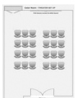 | 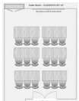 |  | 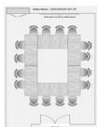 | 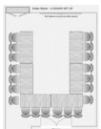 | 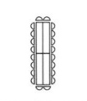 |  | 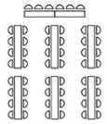
☐ | ☐ |  | ☐ | ☐ | ☐ |  | ☐
# Tables 20 max |  | # Chairs 80 max |  | Podium ☐ |  | Easel ☐

Tech Equipment Available
☐ Projector/Screen/DVD | ☐ Pointer/Slide - Advancer
☐ Laptop (for use with projector) | ☐ Microphones with speaker system

Equipment and Fees
Room fee includes use of tech equipment and staff assistance.
Staff assistance must be requested before the event.
Request staff assistance? ☐ YES ☐ NO

Room Fee (4 Hours) | $130

Signature here
Responsible Party

